Dear diary,

A quote from my notes I wrote moments ago:

“

You have to refine your wardrobe when you want to be minimalist which causes you to have to choose only a few shirts and pants that you continuously trade wearing. This almost forces you to choose a niche style or specific look to be known by, since its very few outfits to cycle between. I like that because it’s forced me to choose the clothes i actually want to keep which is boho and natural and hippie and minimal and comfy. Now I know the kind of style I have actually always wanted to have, and I’ve taken it. Forcing functions work, and I’m slowly creating the lifestyle that I want for myself.

I can’t stay away from smoking

... I don’t even remember typing that.

“

I think I might have a problem. I impulsively went and took weed from Sam’s car when he wouldn’t let me smoke with him (because I asked him to help me quit) but I couldn’t go a day without smoking so I took some. I didn’t have anything to smoke out of because I finally chucked my pipe into a garden so I couldn’t find it and smoke out of it like I did with the j that I kept throwing out and returning from the yard clippings bin. I have been NEEDING to get high lately. It’s really inhibiting my ability to work.

Okay outside of the smoking thing, I must say that I have really just been so inspired reading my journal entries from one year ago at this time. It was around the time that grandpa had passed away. I remember I felt so determined and motivated and passionate about life. I NEED to find that again. I think I will in Thailand.

A year ago I was so optimistic for the future, and I knew that it wasn’t going to be easy. I even said I expected it to take a year or two for me to finally become the person I want to be. But I called it. I would definitely say I’m closer to the person I want to be than I’ve ever been in my life. It’s baby steps, and I’m cultivating the life that I want to live.

I’m having a hard time coming up with what to say. I’m pretty high. I smoked with josh so I could use his bong. It was nice to bond with him though. Also I have been pretty stoked about how many professors have been getting back to me (From *Fallesi’s* recommendations too!!), very unexpected.

I don’t think I could see myself ending up in North Carolina, which is a shame because this professor seems really fucking intriguing to me…. Honestly I need to read through his papers and get a good sense for the kind of mentor he could be. If he seems like someone that would be really beneficial to take on for guidance at this point in my career, maybe it wouldn’t matter where I ended up. I’ll know more from talking to him on Friday, either way I want to be over prepared if I can be.

It’s funny, this week I have an interview with a research lab (Center for Open Science, I had it this morning. I think it went well!), and interview with a company from Industry (Google), a meetup with a girl that I am a mentor to (Alex, from Nicholas’ class), and a professor (Menzies, possibly also Michele from Italy… I should try to make that happen actually).

All different kinds of people with different kinds of opportunities. I honestly don’t know which path I’d rather follow. Four woods diverge in a yellow road…

Which one will I take?

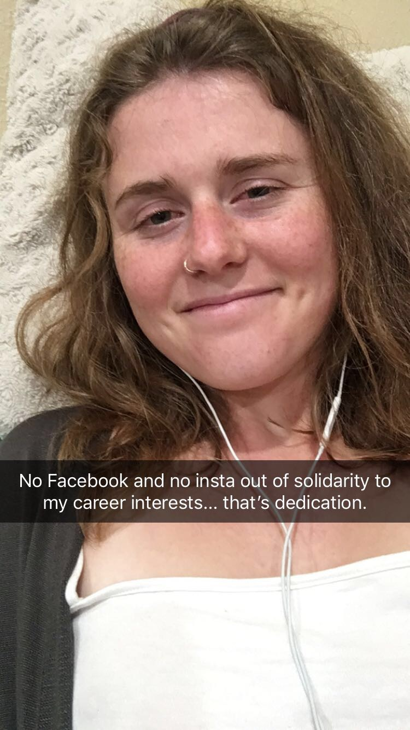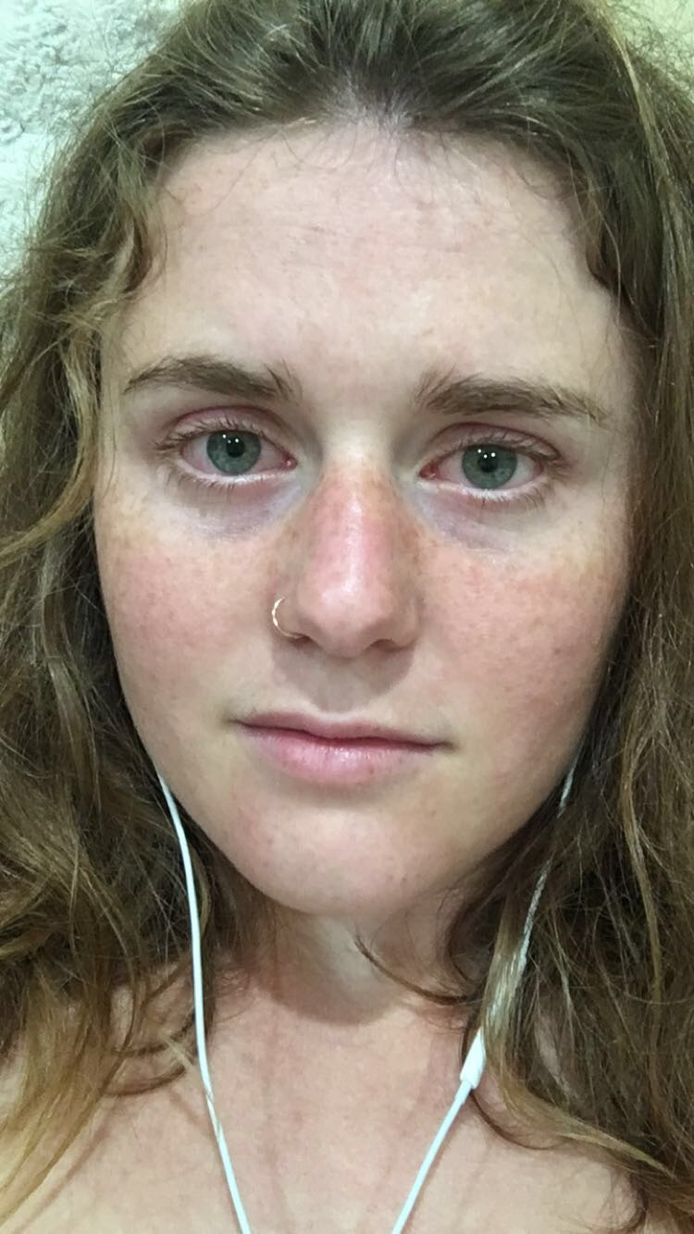

Me, right now. I think I should take pictures of myself more often next to the kinds of things I’m doing with my lifestyle. I wonder if I’ll find any associations with my attitude and looking more tired or disheveled or if I’m happy and I’m glowing.

Right now I just look high.

I’ve been really working on my writing lately. I’m becoming a much better writer. My articles are gaining at least a little bit of attention, which is pretty cool to feel. It’s awesome that people actually read my writing just to learn something and for their *entertainment*. I am going to continue posting one blog a week. Tuesdays are my blog days, no matter what.

Yeah, I’ll need to write more. Shits been a little fucked up in my life, but at least I’m not judging myself. I’m surprisingly chill and happy, I’m just falling behind in grad school stuff but I’ll figure it out!!!

Soon,

Jessie Smith

I’m 22 now